.
- .

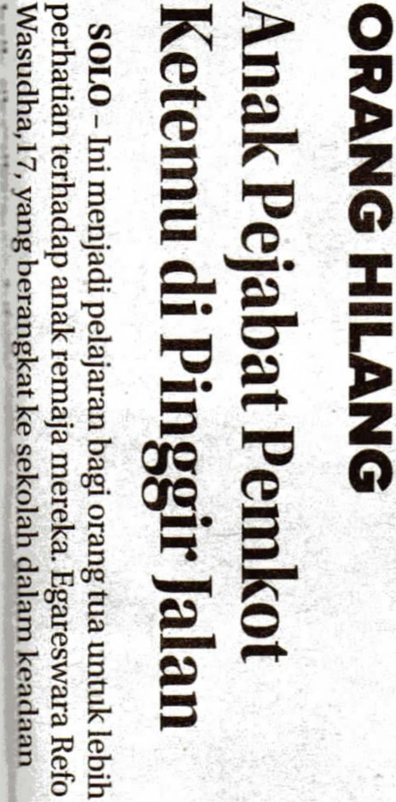. · ·
.

. .

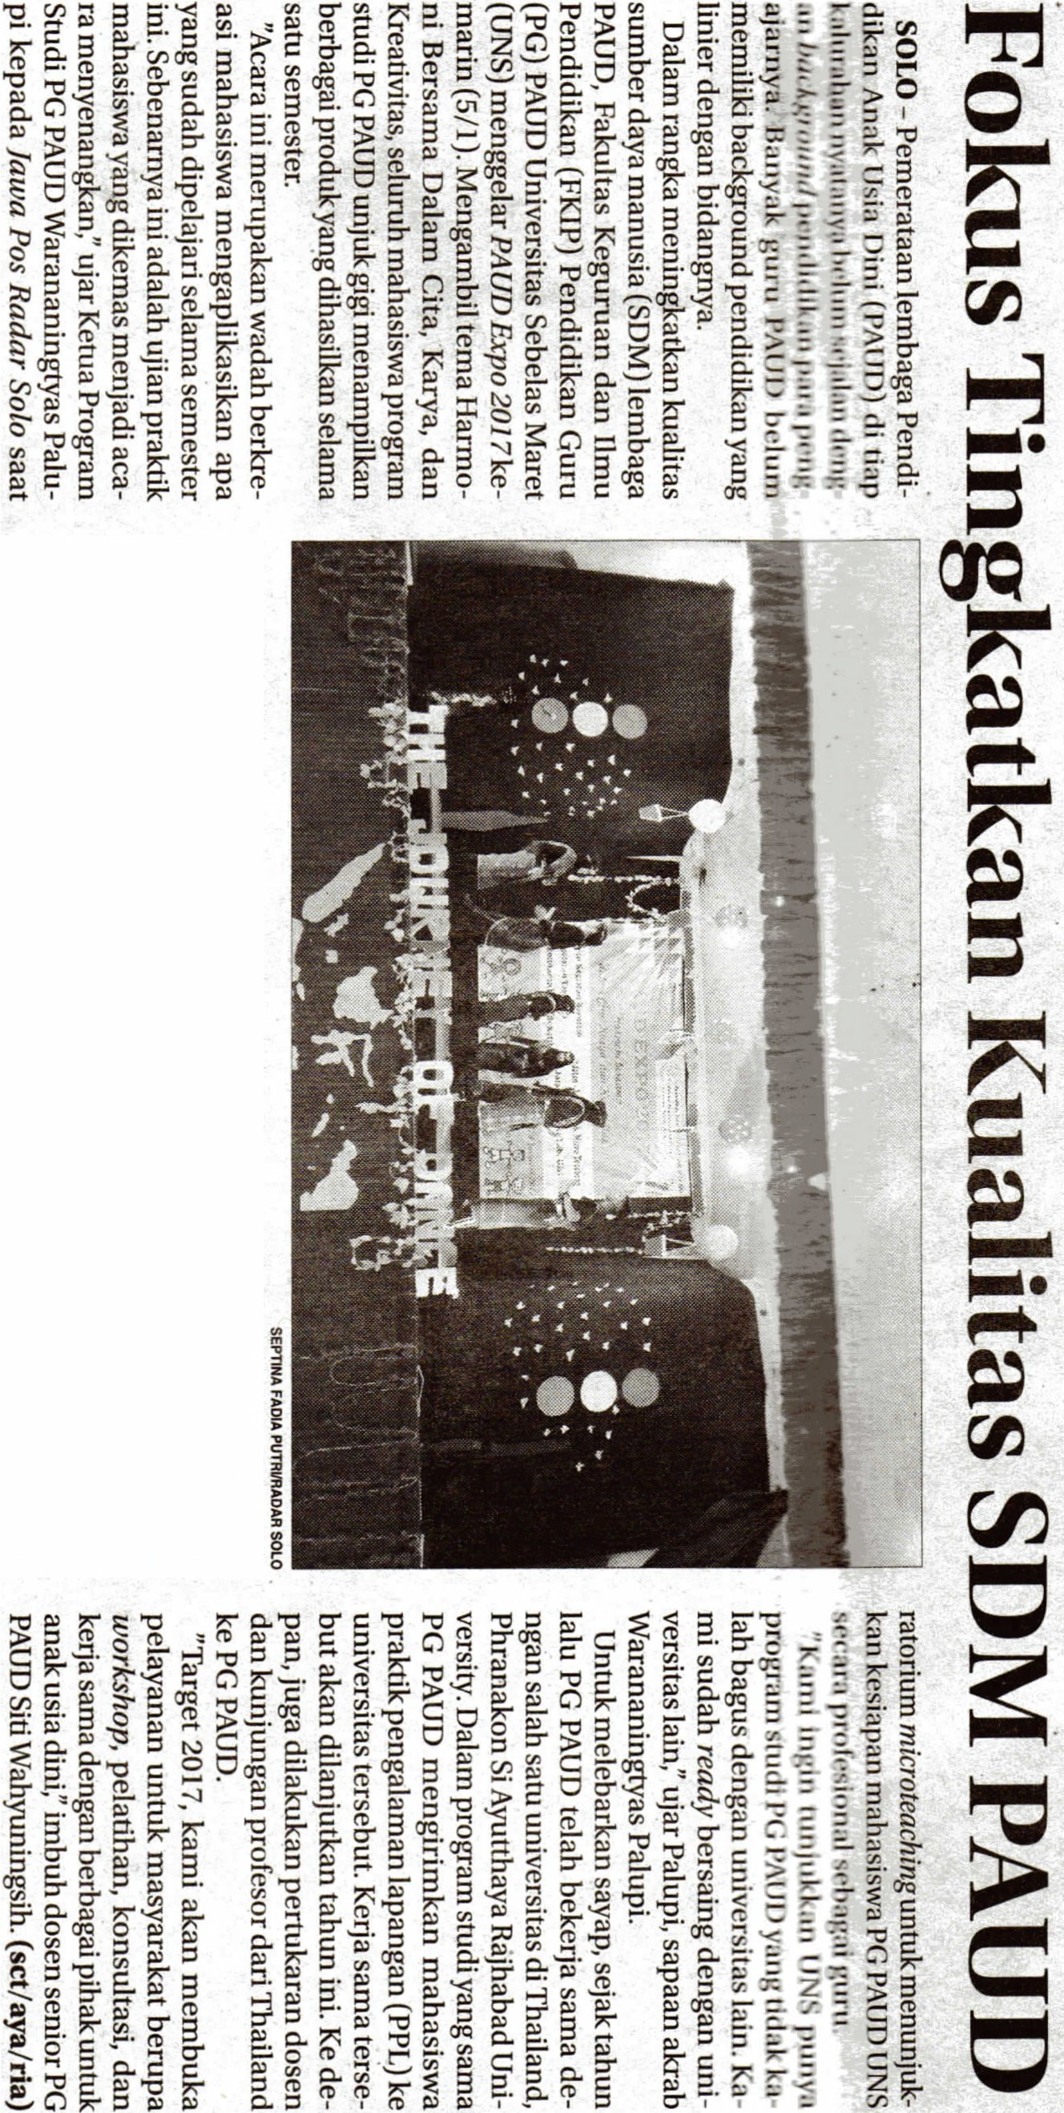.

.... O.C"~ 0. .,,
""::s a"""" :E ('!)::i o:, ::.: ::0
as~~ ('!)g.s11) J>~
'Op.)~ 3 § S "'"E""e:
-!
~
~ ,.... er~~
3:::
....3 ""[&('!) el e:~"' QI
J
e: - "" ;;; E. ~ QI
::s §-OQ :E "' "'iii'
§ (t,....,e: ""en ""~ ~~ QIs
('!)0. 3 ""n, ('!)3 s ""n .,,
Ci)
~""~ § ('!)"''Cl~ "" ~
"" '< ~ c
a~§:.; c
0
'< g.OQ .!..i C) c
""::s""'Cl 3 3 ~ z
Ill
(7Q 3 ""
e:('l)~s§('!) c:
2
I I I I c:
'11:'
U'l § - "" ,.,. .., IC
('!) c ::s § "" ie
i;;;-""~s )';'" ~ 'Cl ~ a.
2 (7Q::s a~"" "'('!) s 3
- ~ s ca "" QI
::s iii

-
O.Q..C"§:"'"" ~
t:.: -· c ,.,. ;::; c
""~ O'c "".... OQ('!) """' 0
~ 3 0:, ~- ;;;· m
""::se:~('l)p.):E ::s "" x.,,
C"
-·~~::,'Ci;;-O'"" "" ('!) i "'0-
~i;;;-§~c-C 0

l")"" ""-· ......
i:i"S~3~3 ~
~e: s::i ?...."" e- 11)3 3
3
- 11) ~
"" 6ei::sc-·OQ 0. ;i'
C"9 ~· ~ ~ -E. ~.
!""° ~ ~ I

· :
·- -
.
. ·

.

.

'

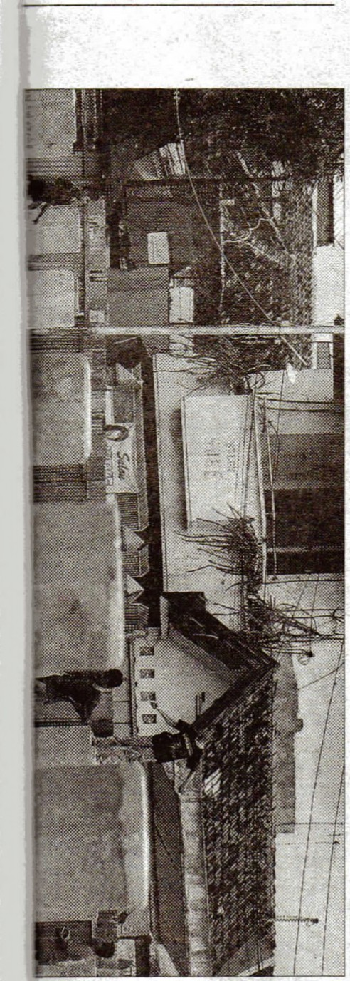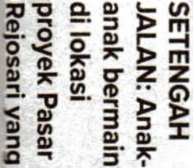

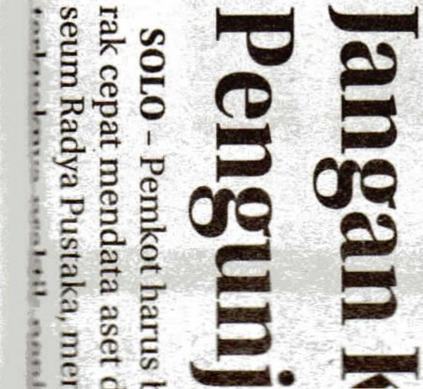~ c z
9
l

c: IC QI
"3:'::
c:
"'
11)
c:
3
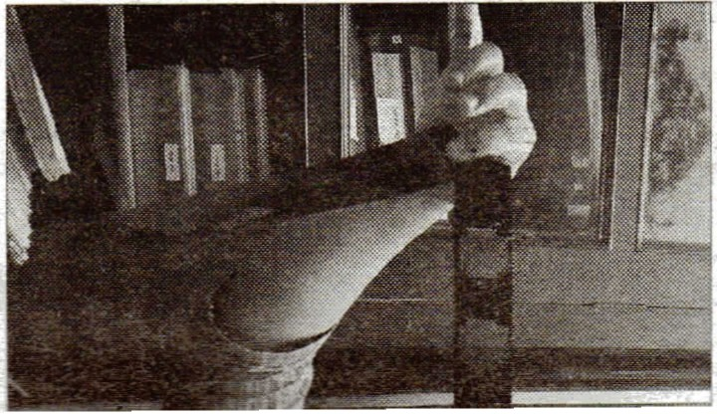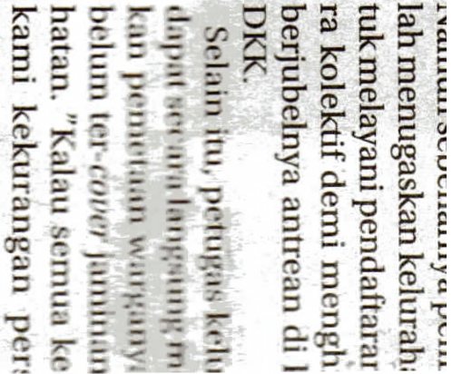::0

